**Ismail Dairy Product**

Skimmed **Milk Powder**, fresh cream, ghee, butter **milk** etc.

Dairy farmers are in the **business of producing food**. They aim to ensure that the safety and quality of their raw milk will satisfy the highest expectations of the food industry and consumers

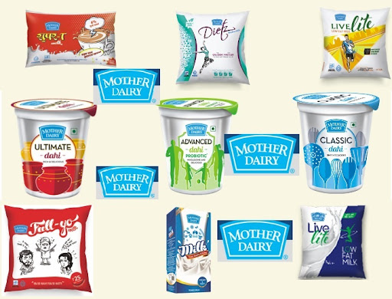

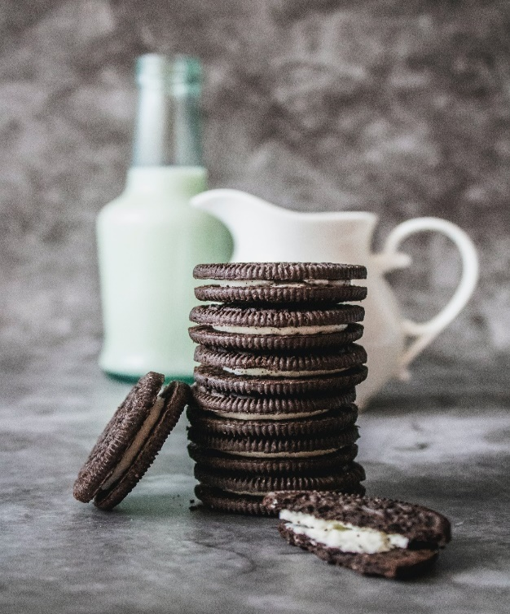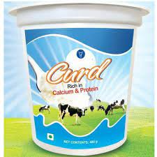

**Requirements**

**Date**

**category**

**Products**

**Quantity**

**UOM(unit of measure, kg ,liter,pkts)**

1.Wants a milk products table webpage on react js to book the items.  
2. On the top of the table needed the name (i.e. for which items belongs).  
3. After the name needed the company name (XYZ Company).

4.There have almost 10-12 milk items/products table list.  
5. Wants product list separated by their category and product name.  
6. wants the input boxes to enter the quantity of product.  
7. On submitting wants to be print the total milk quantity.  
8. Also wants a delete/edit button  
to remove selected items

**Wire Frame**

**Category Product Quantity UOM**

**Edit**

**Edit**

**Edit**

**Edit**

**Edit**

**Edit**

**Delete**

**Delete**

**Delete**

**Delete**

**Delete**

**Delete**

**submit**

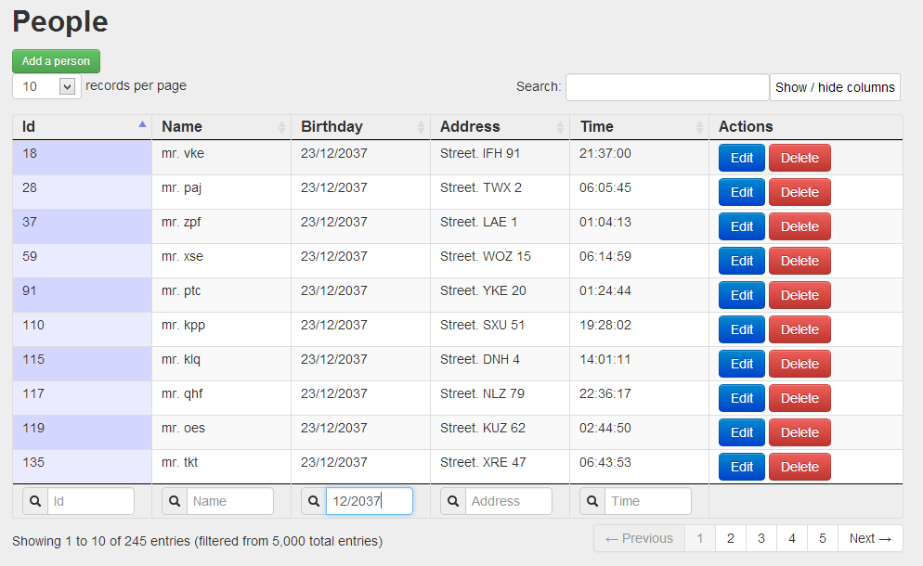

**Tech Stack:**

* **Basically ,as the requirement there are React Js Library is Used.**
* **1. React Js.**
* **2. React Bootstrap => {Table, Button etc}.**
* **3. JavaScript.**
* **4. Use State**
* **5. Local Storage.**
* **6. Use Effect => {to set data in local storage}, etc.**

**Estimated Hours To Understand Topics And Complete**

**The**

**Assignment:-**

**10-12 Working Hours**

**Problems Faced and Solution:**

1. Quantity Boxes.

2. How to get values from quantity boxes and set them in our data variable.

3. How to get data to show in Selected items.

4. How to show the selected items

5. How to show Total of Selected items.

**Solution:-**

1. Added Input Boxes at there position.

2. To solve this issue Used states and to set in our data variable used set State.

3. Here I use the use Effect to store the data in local storage for get to show selected items.

4. For that I get the data from local storage at their I store, And

5. For this problem I store the selected items values in a array and use the method *1 to convert there values in number and then takes a variable and store the total of them and execute that inside our table data.